Faculty of Information and

Communication Technology

ITCS210-Exercise

You need to custom a Google Map to display these following conditions.

1. Display the map of ICT Building, Mahidol University.
2. Set a polygon around the building.
3. Set a marker to the building.

The maps should be similar to the picture below.

**Example of expected result**

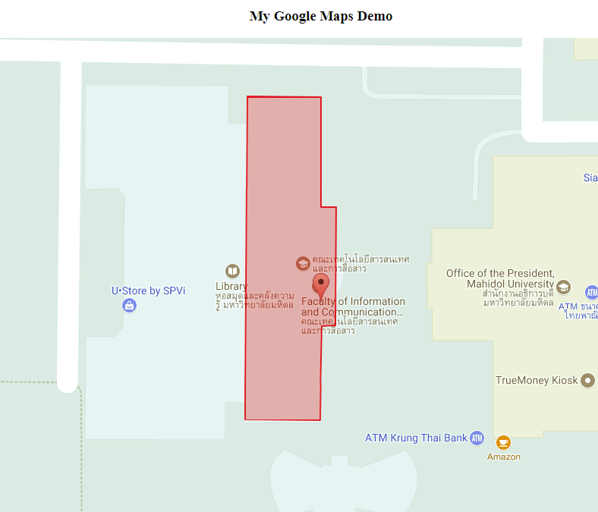

Hint! If you have no idea how to achieve this, you should start from <https://developers.google.com/maps/documentation/javascript/adding-a-google-map>